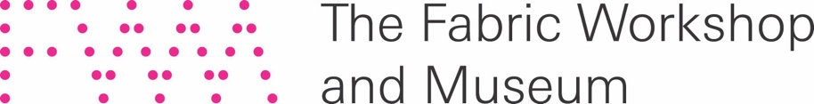

FOR IMMEDIATE RELEASE

FWM Receives Grant from The Pew Center for Arts & Heritage
to Support New Project by Philadelphia Artist Jayson Musson

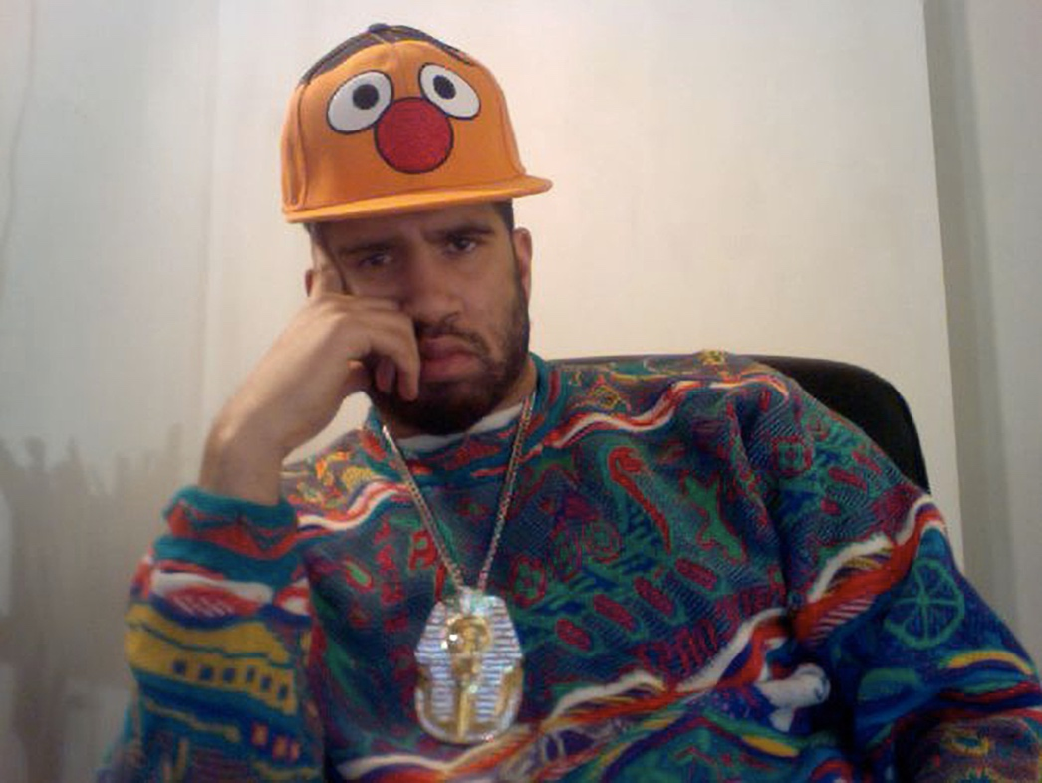

Still from ART THOUGHTZ with Hennessy Youngman: How to Make an Art, 2011.
Digital video, 3:33 minutes. Courtesy of the artist and Salon 94, New York. © Jayson Musson

Philadelphia, PA, October 21, 2020 — The Fabric Workshop and Museum (FWM) has been granted $323,520 in funding from The Pew Center for Arts & Heritage in support of His History of Art, an interdisciplinary project by contemporary artist Jayson Musson. The Project grant is for $269,600 plus an additional 20 percent ($53,920) provided as unrestricted general operating support. Collaborating with FWM on the development of a satirical art history survey with the guidance of television professionals, Musson will create a new miniseries, complete with newly designed sets positioned as installations at The Fabric Workshop and Museum. The project—designed as a two-year residency—will culminate as an exhibition opening in April 2022.

“As our city rebounds from the devastating effects of Covid-19 and the resulting recession, while simultaneously working to dismantle systemic racism in its cultural sector, part of FWM's vision is to provide meaningful exchange between local artists and the public,” states FWM Executive Director Christina Vassallo. “Thanks to the generous support of The Pew Center for Arts & Heritage, we’ll be able to creatively engage visitors from Philadelphia and beyond through the lens of Jayson Musson's ambitious project.”

From 2010 to 2012, Jayson Musson became an internet sensation with ART THOUGHTZ. Over the course of 20 YouTube-based performances, Musson (through his character Hennessy Youngman) incisively satirized both pop culture and art “insiders,” exposing the elitism of the art world and critiquing contemporary art while offering new ways of understanding the cultural landscape he traversed. Ten years later, art institutions are re-examining their role and acknowledging the fault lines in their foundation. Yet at the same time, the fundamental instrument of validation in the art world—the field of art history—remains narrow in scope and entrenched in a Western, male-dominated canon. This will be the focus of Musson’s next cultural critique, with an approach that equally informs and interrogates through his signature humor and accessibility.

Investigating the ways in which popular art historical images impact our cultural consciousness, His History of Art will explore the key question: In what ways can humor address inequality in the arts? "With Jayson as an Artist-in-Residence with FWM, I wanted to showcase Philadelphia and the incredible work that happens here," says FWM Curator Karen Patterson. "I'm excited to work alongside Jayson to learn the ways in which his research acumen and disarming sense of humor can help us uncover truths about inherent inequities in the field of art history."

“Good humor always moves toward truth,” Musson explains. “This exposure of truth is what causes a joke to resonate with a listener and connect with their often-unspoken experiences and feelings. Jokes uncover, jokes expose, jokes bring into the light things which are oft buried by individuals and a society. Comedy’s propensity to dig up skeletons and parade them in front of an audience with little regard for consequence or moral constraint is one of the main reasons it has been a useful tool in exposing inequality and grand social failings.”

About Jayson Musson
Jayson Scott Musson was born in the Bronx, NY in 1977. He received a BFA in photography from University of the Arts and an MFA in painting from the University of Pennsylvania, both in Philadelphia, also attending the Skowhegan School of Painting and Sculpture in Skowhegan, ME in 2011. Musson is represented by Salon 94 in New York and Fleisher/Ollman in Philadelphia. His solo exhibitions include We Sing in A Dead Language, Zidoun-Bossuyt Gallery, Luxembourg City, Luxembourg (2019); Demon All Day, Salon 94 Freemans, New York (2017); The Truth in the Song, Fleisher/Ollman Gallery, Philadelphia (2016); The Grand Manner at the Pennsylvania Academy of the Fine Arts, Philadelphia (2011); and Too Black For BET, Dazed & Confused Magazine Gallery, London, England (2008). His work has been included in group exhibitions at the Whitney Museum of American Art, Lisson Gallery, and Postmasters Gallery, New York; Whitechapel Gallery, London; Galerie Perrotin, Paris; Grimmuseum, Berlin; Museum of Contemporary Art, Chicago; David Castillo Gallery, Miami; and Yerba Buena Center for the Arts, San Francisco, among others.

Please visit pewcenterarts.org/2020grants for a full list of 2020 grantees and project descriptions.
About the Fabric Workshop and Museum
Founded in 1977, FWM both makes and presents, encouraging artists to experiment with new materials and new media in a veritable living laboratory. Through its renowned Artist-in-Residence (AIR) Program, FWM collaborates with artists to expand their practices, while documenting the course of artistic production from inspiration to realization. FWM presents large scale exhibitions, installations, and performative work, utilizing innovative fiber and other media. Today, FWM is the only US institution devoted to creating work in textile and new media in collaboration with some of the most significant artists of our time.

Major support of FWM is provided by the Marion Boulton “Kippy” Stroud Foundation. FWM receives state art funding support through a grant from the Pennsylvania Council on the Arts, a state agency funded by the Commonwealth of Pennsylvania and the National Endowment for the Arts, a federal agency. Additional support is provided by The Philadelphia Cultural Fund, Agnes Gund, and the Board of Directors and Members of The Fabric Workshop and Museum.

About The Pew Center for Arts & Heritage
The Pew Center for Arts & Heritage is a multidisciplinary grantmaker and hub for knowledge-sharing, funded by The Pew Charitable Trusts, dedicated to fostering a vibrant cultural community in Greater Philadelphia. The Center invests in ambitious, imaginative, and catalytic work that showcases the region’s cultural vitality and enhances public life, and engages in an exchange of ideas concerning artistic and interpretive practice with a broad network of cultural practitioners and leaders.

###

Media Contacts
For interviews, background and images:
David Simantov
Blue Medium, Inc.
Tel: +1-212-675-1800
david@bluemedium.com

Philadelphia-based inquiries:
Erin Sweeny
FWM Communications
Tel: 215-561-8888 x224
erin@fabricworkshopandmuseum.org

